ConnectHub - Contact Manager

TEAM ID: SWTID-2026-7237

TEAM LEADER :

RETHANYA S -Role: Project Manager & API Integration

TEAM MEMBER:

PAVITHRA K- Role : Testing & Documentation

TEAM MEMBER:

NITHYASREE KS – Role: Backend Developer (Authentication)

TEAM MEMBER:

NITHYASREE S -Role: Backend Developer (Contact Management)

TEAM MEMBER:

NIVETHA P – Role: Database & Validation Engineer

1. Project Overview
ConnectHub is a backend web application built with Node.js and Express that solves the common problem of scattered contact information. It provides users with a centralized, organized system to store, search, and categorize professional and personal contacts — accessible directly from a Windows PC or laptop.

Key Objectives
- Secure user authentication and per-user data isolation
- Full CRUD operations for contact management
- Flexible categorization using tags (Work, Family, Friends, etc.)
- Real-time search and filtering by name, email, and tags
- Fast, reliable RESTful API with proper error handling

Target Users
- Freelancers and consultants managing client relationships
- Small business owners tracking vendors and customers
- Students and young professionals building their network
- Developers and managers needing desktop-accessible contact storage

2. Problem Statement
People struggle to effectively manage and maintain their growing professional and personal networks because existing solutions are either too complex, too expensive, or lack the simplicity needed for quick contact organization and retrieval on a desktop or laptop.

Customer | Trying To | But | Because | Feeling
University Student | Store and retrieve contacts on laptop | Most platforms are mobile-only | Need quick access while working | Frustrated
Developer | Get required contacts on laptop while working | Available apps are for mobile | Need a simple, visually appealing interface | Wastes time using mobile during work

3. Proposed Solution
Parameter | Description
Problem to Solve | Lack of an efficient desktop tool to save, organize, and quickly find contacts while working on PC
Solution | A Node.js + Express backend with JWT authentication that performs CRUD operations on contacts — usable directly from Windows PC
Novelty / Uniqueness | Free, structured contact management with add, edit, delete, and search by name, email, or tags
Social Impact | Helps busy professionals see and manage contacts without switching to a mobile phone while working

4. Technology Stack

Components & Technologies
Component | Description | Technology
Application Logic (Write) | Data storage and update operations | Node.js, Express, MongoDB
Application Logic (Read) | Data retrieval and query operations | Node.js, Express, MongoDB
Authentication | Securing API calls and access controls | JWT (JSON Web Tokens)
Password Security | Hashing and securing user passwords | bcrypt
Database ODM | Schema modeling and database interaction | Mongoose
Development | Auto-restart server during development | Nodemon

Architecture Pattern
- RESTful API with MVC pattern (Models, Controllers, Routes)
- JWT authentication middleware on protected routes
- MongoDB with two collections: Users and Contacts
- Indexed fields (email, userId, name, tags) for optimized queries
- Many-to-One relationship: each Contact is linked to a User via userId

5. Solution Architecture
The Contact Manager follows a three-tier backend structure:

Layer | Components | Responsibility
API Layer | Express Routes + Controllers | Handle HTTP requests, validate inputs, return JSON responses
Business Logic | Auth Controller, Contact Controller | Authentication logic, CRUD operations, search functionality
Data Layer | MongoDB + Mongoose Models | Persistent storage for Users and Contacts
Cross-cutting | JWT Middleware, Validation Middleware | Authentication enforcement and input validation on all routes

Database Schema
Collection | Fields
Users | _id, name, email, password (hashed), createdAt, updatedAt
Contacts | _id, userId (FK), name, email, phone, notes, tags[], createdAt, updatedAt

6. Functional Requirements
FR No. | Epic | Key Sub-Requirements
FR-1 | User Authentication & Authorization | Registration (name/email/password), login, JWT token management, bcrypt password hashing, session management, auto-logout, protected routes
FR-2 | Contact Management (CRUD) | Create contact (name, email, phone, notes, tags), view all/individual contacts, update, delete with confirmation, data validation, contact count display
FR-3 | Search and Discovery | Real-time search by name/email/tags, case-insensitive search, search result count
FR-4 | Data Validation & Error Handling | Server-side validation, email format checks, required field validation, user-friendly error messages, duplicate email prevention
FR-5 | Contact Information Management | Name (required), email (optional/validated), phone (optional), notes (max 1000 chars), tags (max 10), creation/update timestamps
FR-6 | User Profile & Account | Current user endpoint, user-specific data isolation, userId association with contacts
FR-7 | Data Persistence & Storage | MongoDB for users and contacts, referential integrity, auto timestamps, DB indexing, hashed passwords, JWT in localStorage

7. Non-Functional Requirements
NFR No. | Requirement | Description
NFR-1 | Security | JWT on all API requests, bcrypt (salt ≥10), injection prevention, CORS configuration, HTTPS in production, passwords never exposed in responses
NFR-2 | Reliability | Graceful error handling, resilient DB connections with auto-reconnect, appropriate error messages on failed requests
NFR-3 | Performance | API response <200ms average, optimized DB queries with indexing, smooth UI rendering (60fps), bundle size <500KB
NFR-4 | Scalability | Support 10,000+ concurrent users, 10,000 contacts per user without degradation, horizontally scalable database
NFR-5 | Maintainability | Modular code, consistent style guidelines, meaningful comments, documented API endpoints, version control with meaningful commits
NFR-6 | Compatibility | Chrome/Firefox/Safari/Edge (latest 2 versions), iOS 12+, Android 8+, responsive from 320px to 2560px
NFR-7 | Data Privacy | Per-user data isolation, no third-party data sharing, GDPR compliance (data minimization, purpose limitation), user consent

8. Project Planning (Sprints)

Product Backlog & Sprint Schedule
Sprint | Epic | Story No. | Task | Points | Priority | Member
Sprint 1 | Project Setup | USN 1 | Set up Node.js project with dependencies | 10 | High | Mehul
Sprint 1 | User & Contact Schema | USN 2 | Create Mongoose schema models | 10 | High | Mehul
Sprint 2 | Controllers | USN 3 | Create auth and contact controllers | 10 | High | Mehul
Sprint 2 | Middleware | USN 4 | Create JWT auth and validation middleware | 10 | High | Mehul
Sprint 3 | Routes | USN 5 | Create auth and contact CRUD routes | 10 | High | Mehul
Sprint 3 | Server File | USN 6 | Create server.js, define API routes | 10 | High | Mehul
Sprint 4 | Debugging & Testing | USN 7 | Debug project and test all APIs | 10 | High | Mehul

Sprint Tracker & Velocity
Sprint | Total Points | Duration | Start Date | End Date (Planned) | Points Completed | Release Date
Sprint 1 | 20 | 1 Day | 13/02/2026 | 14/02/2026 | 20 | 14/02/2026
Sprint 2 | 20 | 1 Day | 14/02/2026 | 15/02/2026 | 20 | 15/02/2026
Sprint 3 | 20 | 1 Day | 15/02/2026 | 16/02/2026 | 20 | 16/02/2026
Sprint 4 | 20 | 1 Day | 16/02/2026 | 16/02/2026 | 20 | 16/02/2026

9. User Stories
User Type | Story No. | User Story | Acceptance Criteria | Priority | Release
Student | USN 1 | As a user I can add and update contacts at any time | Fast addition and update | High | Sprint 1
Developer | USN 2 | As a user I can search for contacts fast | Fast search results | High | Sprint 1
Manager | USN 3 | As a user I can view and update team contacts as required | Fast update and fetch | High | Sprint 2

10. User Acceptance Testing (UAT)
Testing Period: Feb 15–16, 2026 | Version: v1.0

Test ID | Scenario | Test Steps | Expected Result | Actual Result | Status
TC-1 | User Registration | POST /api/auth/register with name, email, password | 201 Created — JSON with user details and JWT token | 201 Created — JSON with user details and JWT token | PASS ✓
TC-2 | User Login | POST /api/auth/login with email and password | 200 OK — JSON with user details and JWT token | 200 OK — JSON with user details and JWT token | PASS ✓
TC-3 | Add New Contact | POST /api/contacts/ with contact fields in body | 201 Created — success:true, contact object with userId | 201 Created — success:true, contact object with userId | PASS ✓
TC-4 | Update Contact | PUT /api/contacts/:id with updated fields | 200 OK — success:true, updated contact object | 200 OK — success:true, updated contact object | PASS ✓
TC-5 | Delete Contact | DELETE /api/contacts/:id | 200 OK — success:true, 'Contact deleted successfully' | 200 OK — success:true, 'Contact deleted successfully' | PASS ✓
TC-6 | Search Contacts | GET /api/contacts/search?q=<query> | 200 OK — success:true, count, contacts array | 200 OK — success:true, count, contacts array | PASS ✓
TC-7 | Get Current User | GET /api/auth/me with JWT in Authorization header | 200 OK — success:true, user id, name, email | 200 OK — success:true, user id, name, email | PASS ✓
TC-8 | Validation Error | POST /api/auth/login without password field | 400 Bad Request — errors array with field and message | 400 Bad Request — errors: [{field:'password', message:'Password is required'}] | PASS ✓

11.

Result: output:

Screenshot 1: Register API (POST /api/auth/register) → 201 Created with JWT token and user details

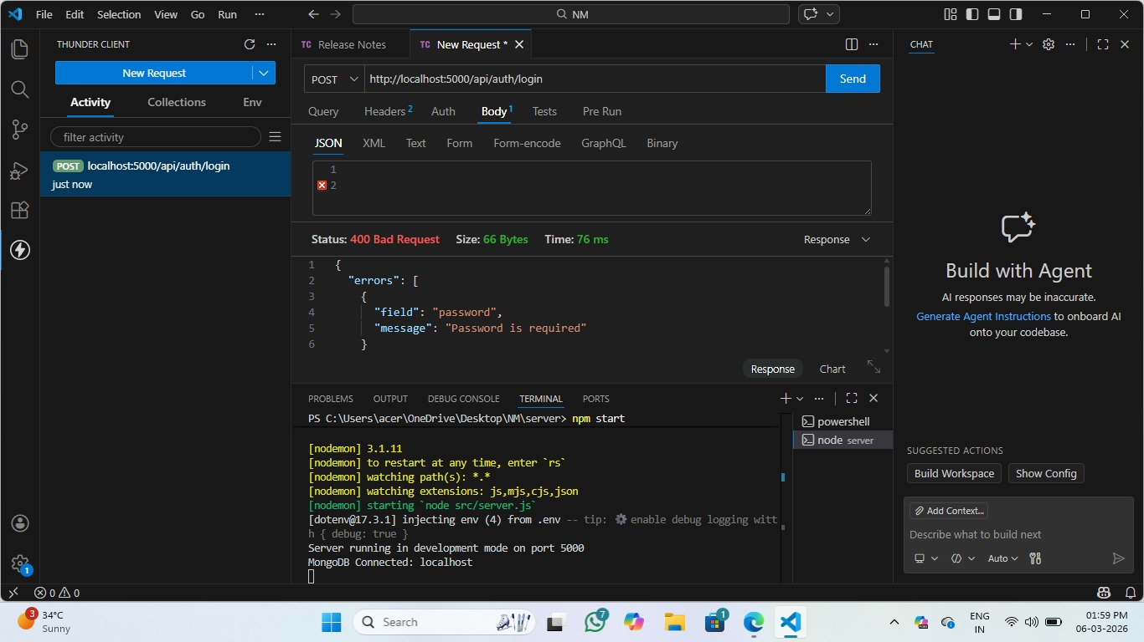

Screenshot 2 — Login API (POST /api/auth/login) → 200 OK with JWT token

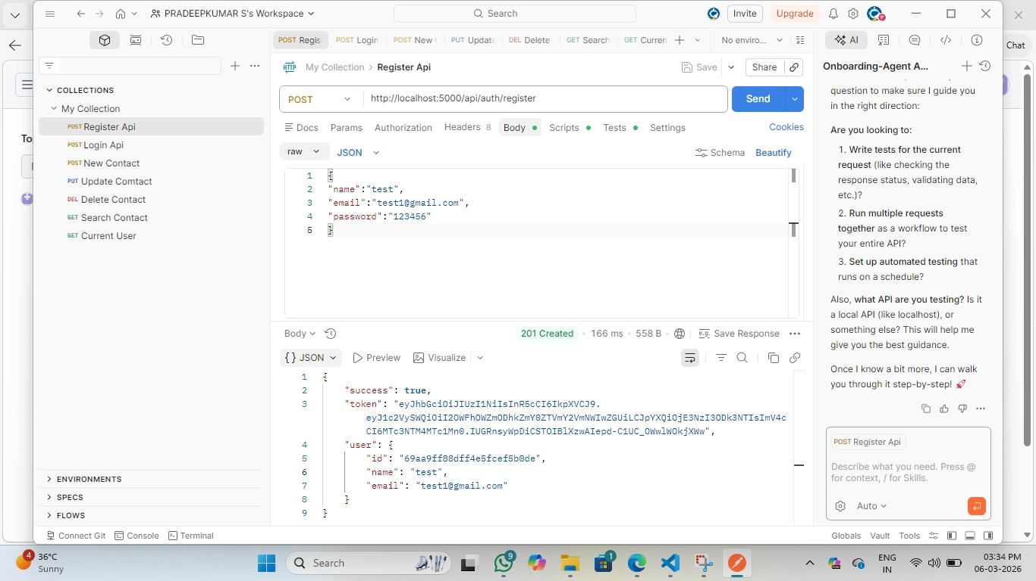

Screenshot 3 — Validation Error (POST /api/auth/login without password) → 400 Bad Request

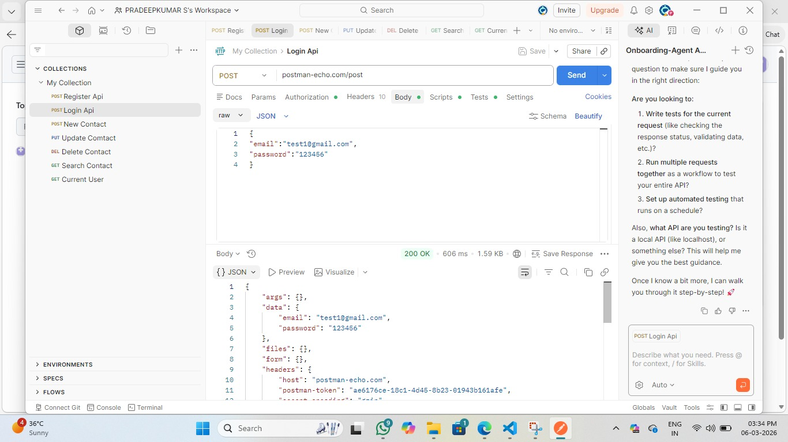

Screenshot 4 — New Contact (POST /api/contacts/) → 201 Created with contact object
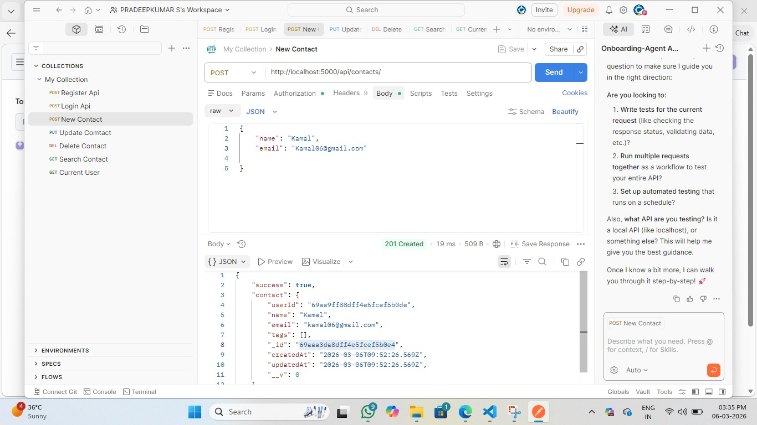

Screenshot 5 — Update Contact (PUT /api/contacts/:id) → 200 OK with updated contact

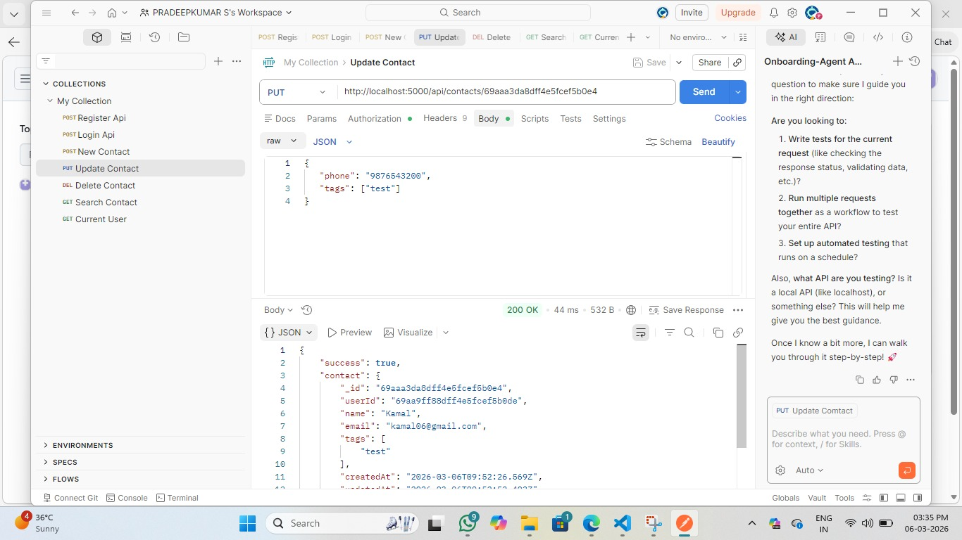

Screenshot 6 — Delete Contact (DELETE /api/contacts/:id) → 200 OK — Contact deleted successfully
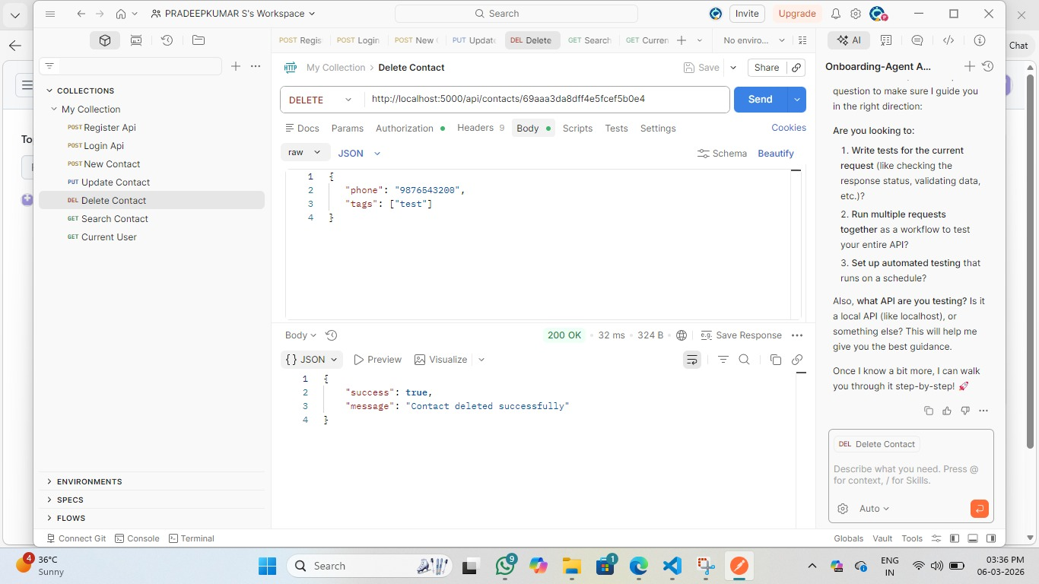
Screenshot 7 — Search Contact (GET /api/contacts/search?q=test) → 200 OK with count and contacts array
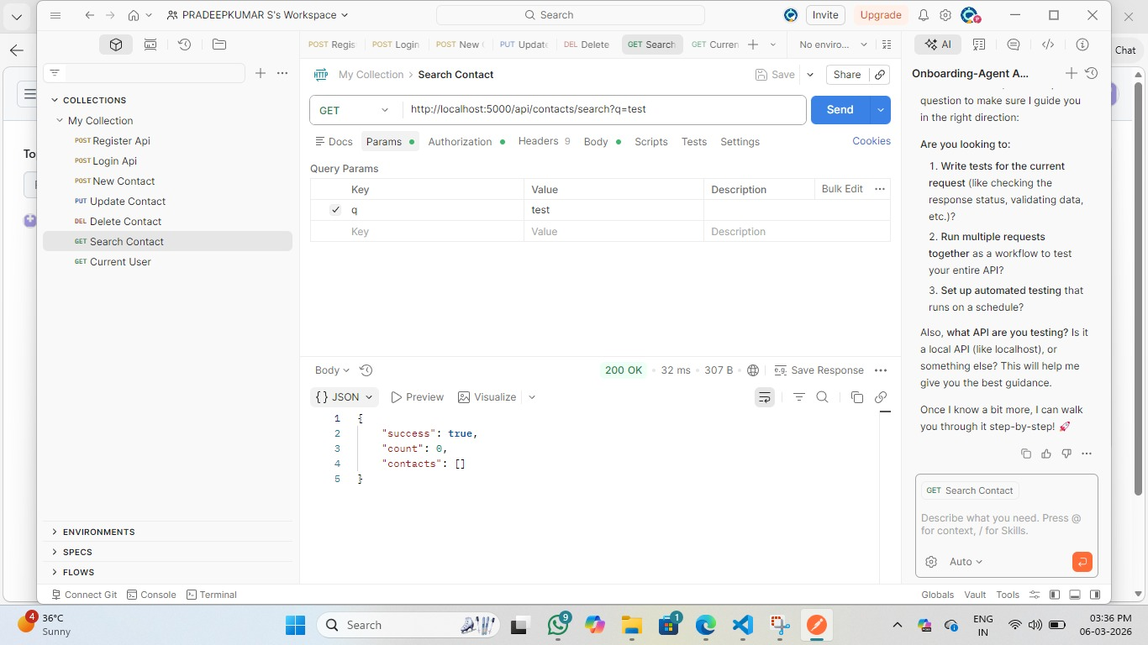

Screenshot 8 — Current User (GET /api/auth/me) → 200 OK with user id, name, email
